Antiques
CHINESE EXPORT PORCELAIN I
BLUE AND WHITE

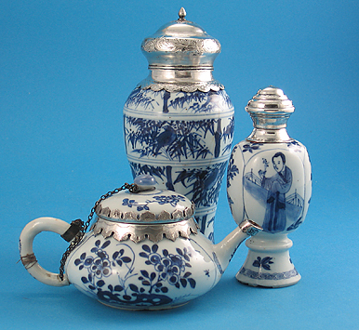
By Millicent F. Creech

China has an amazing history in the field of ceramics, having produced the first wares as early as 6000 B. C., and having exported to neighboring countries as early as 450 B. C. However the term Chinese Export refers particularly to the 300-year brisk trade between England, Europe and America between 1520 and about 1820. The most prized of the earliest imports to the West, brought back as cargo in wooden sailing vessels, were tea and silk (above the waterline), and, in the hold for stability, a commodity that was to become considered not only more precious than gold and silver, but by the year 1700, the measure of a gentleman's status in the world - Chinese export blue and white porcelain.

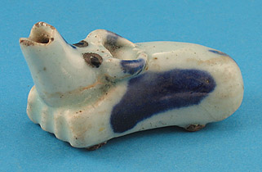
Early History : In 1279, the Mongol warrior Genghis Kahn penetrated the Great Wall of China, conquering the lands from the Sea of Japan on the east to the Black Sea on the west. He founded the short-lived Mongol Yuan Dynasty, (1279-1368). This empire included parts of Russia, India, and more importantly to ceramics, Persia. The Persians revered blue and white ceramics, and although having the necessary cobalt (the source of the blue color, which prior to firing, looks more like a think pink calamine lotion), they could not stabilize it in firing. So by way of Middle Eastern merchant sailing ships, they sent to China, known for her prowess with ceramics, a bright blue-firing cobalt, along with Egyptian metalwares as guides for shapes. These very vibrant and densely decorated porcelains were first produced at the Jingdezheng (Ching-te-chen) kilns in China about 1330. The Chinese were Buddhists, and used to monochromes (single colored ceramics), as celadons, and whitewares used in the Buddhist religious rites. They regarded the new blue and white garish, tacky, and completely unsuitable for domestic use. Occasionally they used the cobalt domestically as small dots to cover firing flaws, as on the

Above left: Three Kangxi silver-mounted blue and white wares, c1690, the silver mounts Dutch; most silver mounts were applied prior to 1740.
Above right: Yuan oxen form water dropper with blue spots, 14th century, 3” Long
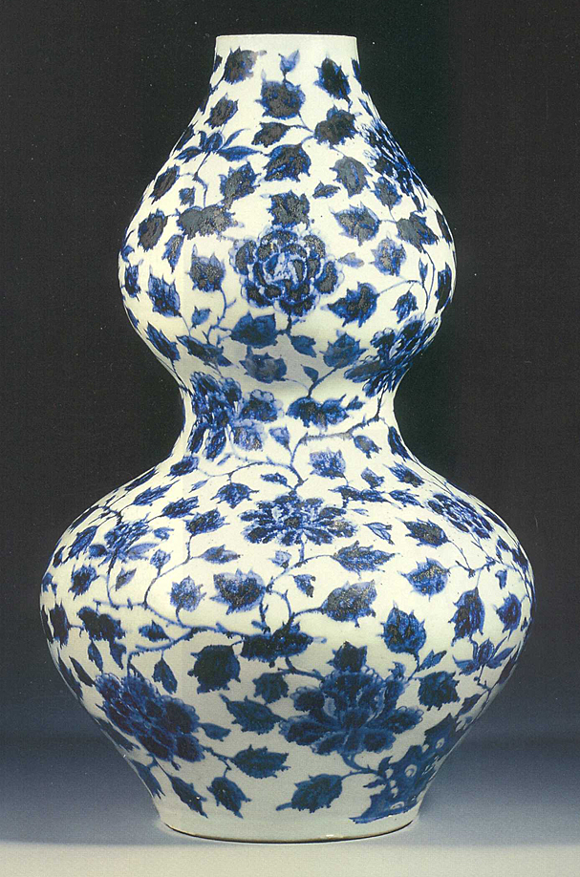
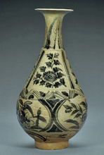
13/14th century water dropper (pictured above). The finest of this early blue and white resides in the Topkapi Museum in Istanbul. One exception was in the province of Yunnan, which had a Moslem mayor. Local cobalt ores containing iron and manganese were used to produce blue and white wares there. The result was an inky blue-black over a celadon colored ground (right).

Left: Yuan Dynasty Double Gourd Vase, Persian Market, 14c, 20.25”
Right: Yuan Dynasty Bottle Vase, Yunnan Province, 14th Century, 10.75”

Ming Export to the West : Most of the blue and white existing today dates from the mid-1400's. When the Ming Dynasty regained control from the Mongols in 1368, they restored the native values and tastes (including the ceramics), became quite insular, even closing the ancient Silk Road for a time. But in 1465 the Emperor Chenghua, a great patron of the arts, reopened China and gave imperial patronage to blue and white ceramic production. Some of the finest ware ever produced bears his nian hao (reign mark).

Only 24 years later (1489), Vasco de Gama found the sea route to China, returning to Portugal with the wondrous blue and white "china", so called because of its source. This was a cargo that would change the history of the Western world forever. Europeans were then dining from buff or grey earthenware, pewter, wooden trenchers, (hollowed out wooden bowls). Silver might be on the table of only the wealthiest. Never had anyone seen anything so fine, so white, so hard, yet impervious to heat. Princes were counseled to use porcelain over silver - "a material so fine and translucent that its beauty is as glass or alabaster…having a decoration which appears to be a mixture of alabaster and sapphire".1 Immediately the Portuguese sent ships called "carracks" to China, bringing back all the new blue and white china the boats could hold. Special orders for royalty and the Papacy were included, often taking more than two
Above right: Rare Kraak Porcelain Charger, Wan Li, Jingdezhen, China, C1575-1605, depicting a cormorant defending her nest from an invading magpie among lotus and other flora, the flat rim with equal segments divided by thin double line, depicting small delicate flowers, birds and insects, the verso with birds on 2 blooming branches; Rinaldi, Type IV, 12-5/8” Diameter
years to complete.

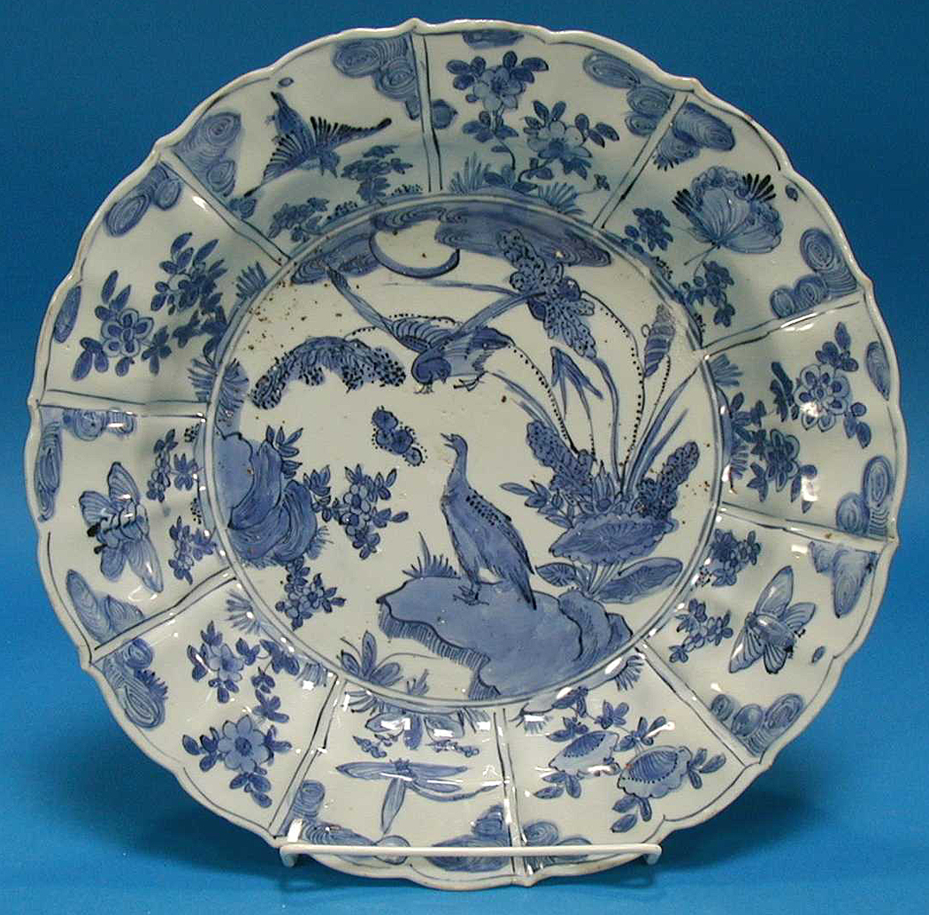
Quickly the Dutch followed the Portuguese. Their boats were similarly named, being kraaks. The name is still being carried today as a late Ming blue and white segmented form of porcelain known as kraak porcelain (above). In 1600 the Dutch East India Company and the British East India Company were founded for the express purpose of commerce with the "Indias", as the eastern lands were also called. In the early 1700's all other major European nations also opened hongs, warehouses or factories on the Chinese mainland to receive and store goods, including the prized porcelains.

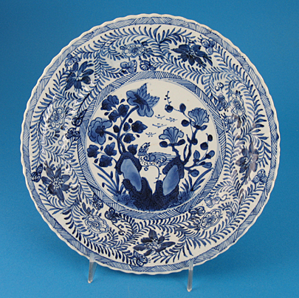
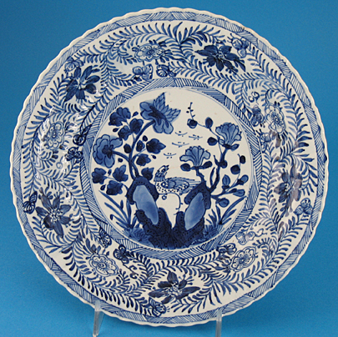
Ming forms exported included bowls, jars, dishes, vases, and candlesticks, many shapes being based on European models and drawings. Early Ming ceramics fired red where the glaze did not cover, later pieces and Fujian Province pieces firing white to buff. The glaze itself can be a greenish or greyish ground, and the cobalt firing to a bright blue, or a smoky grey. Often they placed too much cobalt on the brush, resulting in areas of black that actually broke through the glaze. This was called heaping and piling, thought of as a fault, and finally eliminated in about 1700, only to be imitated in the 19th century by tiny dots. It added tremendous depth and spontaneity to the painting.

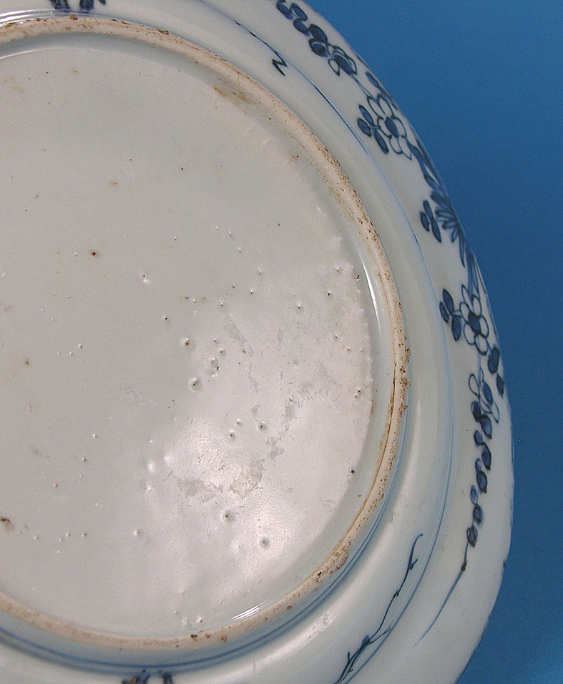
Early Ming footrims were quite low, later becoming very high, and sharply cut with a knife. Often there was sand adhesion from the kiln floor (see above). Designs included sprawling and openly painted with scrolling foliate designs, or segmented radiating panels, sometimes as lotus petals, around a center with flowers, nature scenes, people, or initials. Sometimes the bottom of the porcelains had chatter marks - tiny ridges radiating diagonally from the center (see illustration at right). These are so called because the potters let the ceramics slip on the wheel as they chattered away. These also disappeared by 1700.
Left: Ming footrim, showing sand adhesions and chatter marks
Some Ming exported wares are being excavated from the sea bottom, with varying prices. They will have a little expected glaze matting. It is exhilarating to be among the first in 400 years to touch an object.

17th Century : In the early 17th century, war broke out between the now corrupt Ming leaders and the Manchu's. As leaders had more pressing matters to consider, once again porcelain production declined. However, those who still attended the kilns were able to be fully creative, and introduced the Transitional style, wherein a scene continues around a vessel, as a moving picture. This style is still used very successfully today on vases and jars.

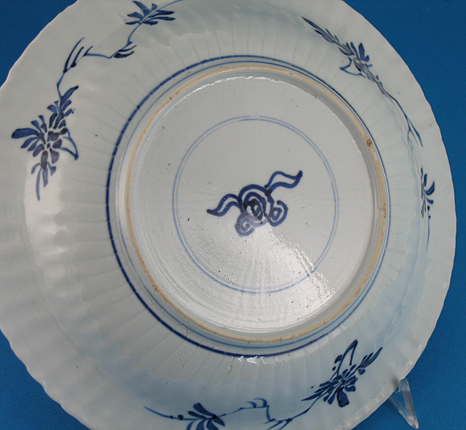
In 1662, Emperor Kangxi of the new Manchu Qing (Ch'ing) Dynasty assumed the throne. Despite the kilns being destroyed twice, his rule produced from 1682 to 1722 the finest blue and white ever produced, both technically and visually. The ceramic became quite thin, with a glassy glaze, the blues even more like sapphires beneath it. Painting was free and precise at the same time. To protect his wares from further Ming destruction, he introduced a marking we still see copied today - that of two concentric circles. These circles often contained a fantasy mark, as a rabbit, leaf, urn, scroll, or such (see above). That way, no one knew just what reign produced them.2 Forms were both of traditional Chinese and European origin. Teawares flooded into Europe and England. Large special-order dinner services, some with coats of arms, were introduced about 1690. Kangxi blue and white was not only the inspiration for Meissen, causing Augustus the Strong of Saxony to threaten the alchemist Bottger with his life should he not find the formula, but for all early European porcelain, as well as Delft.
Above: Kangxi thinly potted and molded plate, depicting a central phoenix amidst rockery issuing flora within flowering fern-like scrolling vines, the verso with a central knot (cash symbol, qian) within concentric circles, also with chatter marks
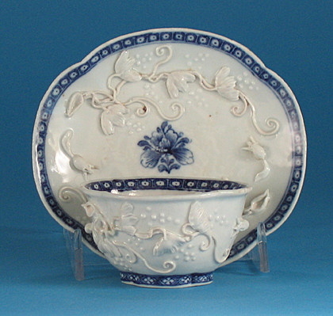
Kangxi porcelains are considered fine paintings on very fine ceramics, and can be used as such. Of course they may be eaten from, if desired. However, their finest value is in adorning walls, tables, mantels, bookcases and cupboards. They may be used singly, or mixed with other ceramics. Prices for a fine blue and white plate will begin about 250.00, less with slight chipping or hairlines. A pair raises the value of each piece.
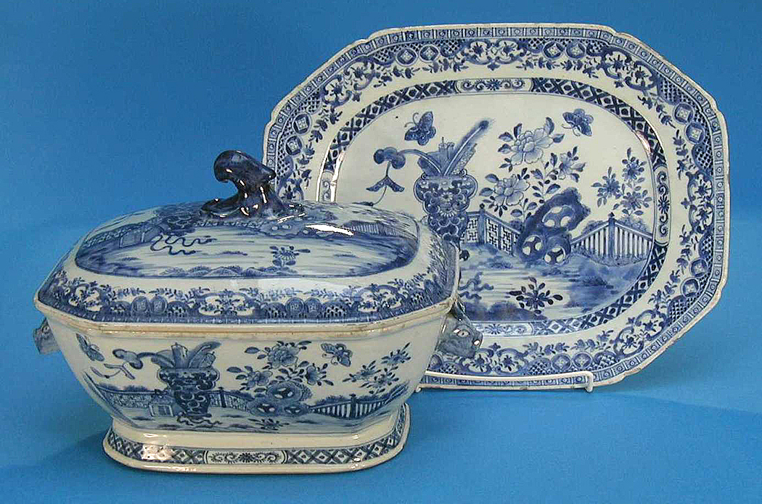
18th Century (Yongzheng and Qianlong reigns) : Blue and white production continued throughout the 18th century reigns of Emperors Yongzheng and Qianlong (the emperor's names usually being used in description of the ceramics), but losing favor in the 1730's to the new pink famille rose palette. Designs remained much the same as Kangxi. Toward the middle of the century, the decoration became quite scenic, with "Nanking" type patterns of pagoda and rocky riverscape scenes, often with bridges and birds. The complex scenes were surrounded by complicated and diapered (with repetitive pattern) borders, often on octagonal notched-corner forms. These were the basis of the famous Blue Willow patterns of the 19th century.

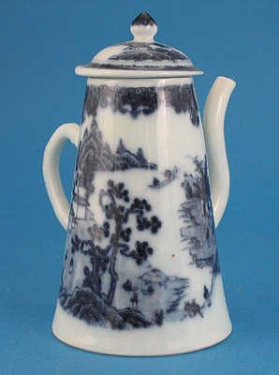
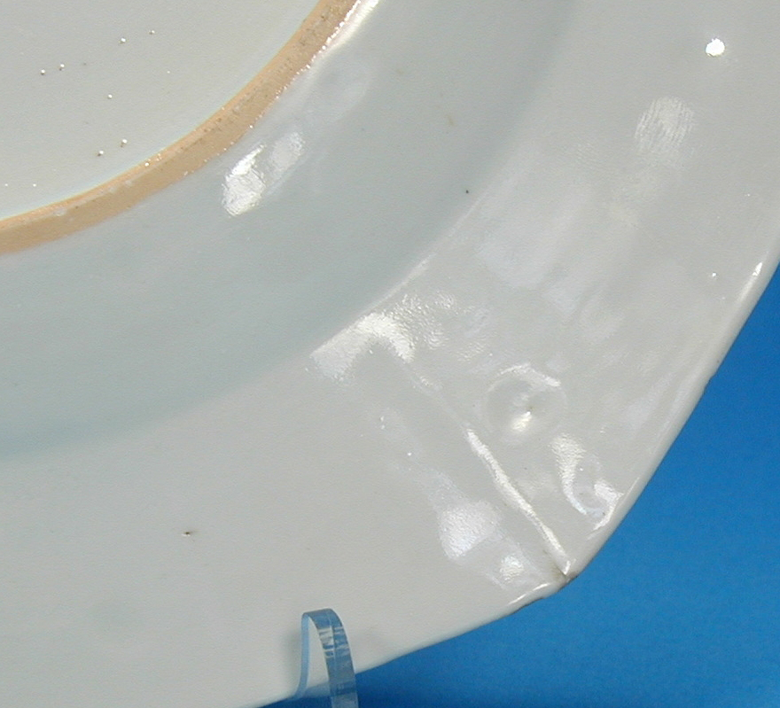
Until about 1750, plates were also decorated on the back. The footrims of earlier 18th century plates, sharply cut in a low V-form, usually turned orange in firing, from the presence of iron oxide in the kiln.
The glaze became thicker, with the orange peel texture introduced c1765.

In the 1790's, the "patterned dinner wares, as Canton (with a rain and cloud border), Nanking (with a spearhead border), and Fitzhugh (lace-like and butterfly border) were introduced. These can still be assembled as quite fine dinnerware. Much of the Nanking (pictured below) was gilded in England, making it quite desirable. The Canton service should be selected with the curved rain and cloud border, rather than the later straight-line border. These dinner services were quite popular in early America, George Washington having an extensive collection of Canton in daily use, and still on display at Mt. Vernon.
Above left: Qianlong Tureen & Underplate, c1765-70, notched octagonal form, depicting a vase in a fenced garden with blue hollow rock, the border with richly brocades floral scrolls, cash lozenges, and scale diapering within a band of cell diapering. Underplate, 14.25” Long
Above right: Qianlong Blue & White Cruet, c1765-70, depicting a pagoda/island/ riverscape, 5.25” H;
Qianlong Quatrefoil Teabowl & Saucer, c1750, with applied lotus and lotus scrolls, 4 7/8” D, saucer;
Footrim c1750 plate, depicting the sharply V-cut rim with orange coloration.

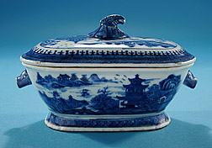
Chinese Export Nanking Diminutive Lidded Tureen, c1800, painted in vivid blue with a pagoda/riverscape within a spearhead and diapered border, the tureen with rabbit-head handles, the lid with a leaf-form knop, Jiaqing Period.

Jiaqing Period and the 19th Century : In 1786 the vessel Empress of China arrived on America's shores with its first cargo from China. This was quite important, as America had no porcelain kilns of it own yet. However, due to the extensive Atlantic crossing, much of the cargo arrived broken. It is said that the American Ambassador complained bitterly of the damage, insisting upon a better transit. Shortly thereafter, the porcelain became thicker-walled. It is possible that the increased sturdiness was in effort to court the American market, as most of the European countries developed their own kilns by the mid-1700's, no longer needing the Chinese exports. And the trade had lessened dramatically.

19th century quality declined rapidly, as the mass production had caused inevitable deterioration. The Dutch had ceased their trade in the 1780's. The British East India Company closed in 1820. Although trade to the Americas and some private English and European trade continued for a while, the Opium Wars of 1839 closed the Chinese ports to foreign nations. It was the end of a brilliant era of history, but lives on for us in the exquisite ceramics that traveled in the dark holds of ships for over 300 years, and survived for us for another 200 years, despite their fragility. I hope you will take the time to find some of this remaining exquisite craftsmanship, and enjoy its heritage soon.
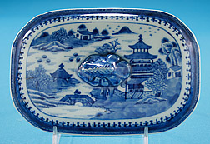

Lid to Nanking Diminutive Tureen, showing in detail the pagoda/ riverscape central scene within the spearhead border, characteristic of the Nanking pattern.

Millicent Ford Creech
M. Ford Creech Antiques
Memphis, Tennessee
www.mfordcreech.com

From a series of 6 articles for “At Home Magazine”:
Chinese Export I: Blue & White

Chinese Export II: Famille Rose
Early English Spoons
Silver Tea Services
Tea Caddies
What’s So Special About the 18th Century?

1 Chinese Blue and White Porcelain, Duncan MacIntosh, p.171, spoken at the Council of Trent, 1562, by Archbishop Dom Bartolomeu.
2 The Chinese copy earlier pieces, as well as their marks; porcelains cannot be assessed or dated by marks alone. The ceramic, glaze, and painting all contribute to the exact dating. Late 19th century pieces will have a red China mark on them, due to the McKinley Tariff Act of 1891.

